PREPARING Two Column Paper With Ms word
Times New Roman, 11pt,
BOLD, CAPITAL LETTERS
Times New Roman, 10pt, BOLD, CAPITAL LETTERS
Underline the presenter
S.G. KIM¹, C.J. PARK², M.S. YANG³, and J.B. KIM³
¹ Position, Department, Name of Organization, City, Country,
² Position, Department, Name of Organization, City, Country,
³ Position, Department, Name of Organization, City, Country,
Correspond to Prof. J.B. KIM (code@code2012.org)
10pt, Italic
Keywords: Maximum 7 Words, Times New Roman, Font Size 10, Italic
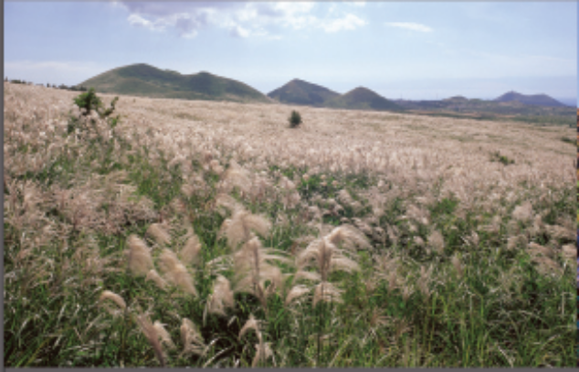

1. GENERAL INSTRCUTIONS
All extended abstracts must be written strictly according to the instructions set here. Please keep in mind that the publisher will print it in black only. The authors’ name should be written the initials first and then the last name. Last name should be capitalized as above. When typing affiliation, type position, department, name of organization, its city, and lastly country.
The size of paper should be A4 and the length for the extended abstract should be not more than two pages in length including the references. Font should be 10 point, Times New Roman with 12 point line spacing for whole document.
Do not bold and underline in any text. Additional space or paragraph between the lines is not necessary. An indentation is needed for a new paragraph when you start one.
Type primary headings in BOLD, CAPITAL LETTERS and secondary headings in bold, lower case, type your extended abstract no more than 2-page including tables, figures, references, footnotes, etc. Specific names, the titles of journals and books should be in italics. For margin setting please refer to Table 1.

Table 1. Use Times New Roman, 10 point size in the table title and table text, and margin setting for A4 size paper
Setting | A4 size paper
Setting | cm | inches
Top | 2.5 | 0.98
Bottom | 2 | 0.78
Left | 2 | 0.78
Right | 2 | 0.78

2. LAYOUT OF TEXT
Locate tables and figures close to the first reference to them in the text and number them consecutively. Avoid abbreviations in column headings. Use Times New Roman, font size 10. Table captions should be placed above the tables. Figure captions need to be placed underneath the figure.
Equations are not required to be indented. Number equations consecutively and place the number with the tab key at the end of the line, between parentheses. Equations should be preceded and followed by a one-line space. Awkward line spacing caused by in-line equations should be avoided.

Figure 1. Use Times New Roman, 10 point size in the figure title and margin setting for A4 size paper
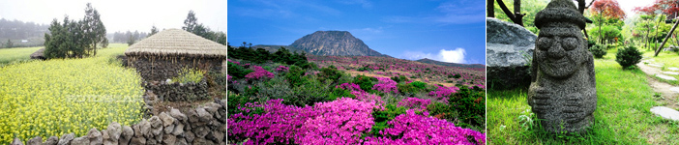
Figure 2. The extended abstract should not exceed 1 page including tables, figures, references, footnotes, etc.

3. CONCLUSIONS
Conclusions should state concisely the most important propositions of the extended abstract as well as the author’s views of the practical implications of the result.

REFERENCES
References in the text should be numbers in square brackets like this [1], and then there should be a key to such numbers at the end, as shown below. These examples also show the expected reference format:

Reference to a journal publication:
[1] J. van der Geer, J.A.J. Hanraads, R.A. Lupton, J. Sci. Commun. 163 (2010) 51–59.

Reference to a book:
[2] W. Strunk Jr., E.B. White, The Elements of Style, fourth ed., Longman, New York, 2000.

Reference to a chapter in an edited book:
[3] G.R. Mettam, L.B. Adams in: B.S. Jones, R.Z. Smith (Eds.), Introduction to the Electronic Age, E-Publishing Inc., New York, 2009, pp. 281–304.

